Version: v2016.1
Returnable Bidding Forms Part II
Purchase of equipment for hairdresser and beauty salons in support of women entrepreneurship
RFQ Ref No: UNOPS-EP-2016-G-018

LOT II –Equipment for beauty salons

Technical specifications for goods – Comparative Data Table

Item No | UNOPS minimum technical requirements | Qty | Is quotation compliant?  Bidder to complete | Details of goods offered. Bidder to complete  Insert details of goods offered, including specifications and brand/model offered if applicable
1. | Electrically adjustable cosmetics bed  Total length: flat 1800-2040mm,  Width: 700-850mm  Seat height: 650-850mm  Backrest: 720-860mm  Weight: 50-60kg  Bed Colour: white  Upholstery: synthetic leather  Electric height adjustment  Electric backrest and foot rest adjustment  Face rest with added cushion | 3 | ☐ Yes ☐ No
2. | Cosmetic bed  Length 1800-1900mm  Width 550-750mm  Height 700-800mm  Weight 20/25kg  Load Bearing Capacity 180-250kg  Upholstery Colour White  Upholstery Synthetic Leather  Face rest with added cushion  Added shelf under bed  Adjustable backrest  Similar to the picture below  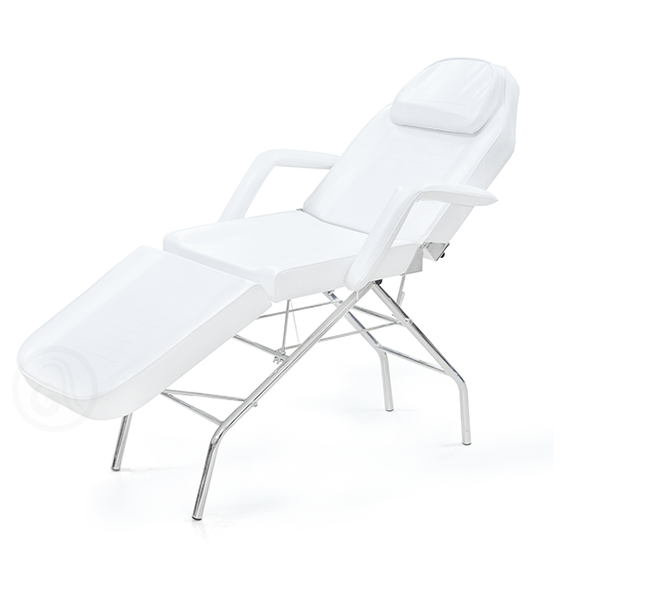 | 2 | ☐ Yes ☐ No
3. | Makeup Chair  High Chair,  Load bearing capacity up to 150kg  Chair weight: 6-8 kg  Colour: white  With backrest  Minimum seat height: 45 cm  Maximum seat height: 80 cm  Minimum backrest height: 75 cm  Minimum backrest height: 110 cm  Padding: minimum 10cm delux cushion  Upholstery: PVC  Similar to the picture below  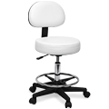 | 4 | ☐ Yes ☐ No
4. | Auxiliary Cosmetics Trolley  Without drawers, min. 4 shelves  Similar to the picture below  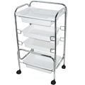 | 3 | ☐ Yes ☐ No
 | Auxiliary Cosmetics Trolley  Minimum 4 shelves, minimum 2 drawers  Similar to the picture below  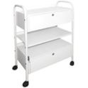 | 5 | ☐ Yes ☐ No
 | Auxiliary Cosmetic Chair  With or without backrest , gas pump, height adjustment, max height 600mm - 800 mm,  min height 400 mm, Colour: white  Similar to the picture below:  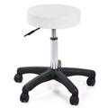 | 3 | ☐ Yes ☐ No
 | Manicure Table  Portable table with a wheel base  2 separate elements, colour: white  6 drawer minimum  Similar to the picture below:  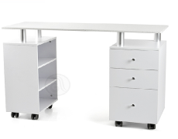 | 2 | ☐ Yes ☐ No
 | Pedicure Chair  Dimensions (LxHxW),minimum 100x50x50cm, Adjustable height,  Colour: white, Upholstery: synthetic leather  Foot rest, fixed or height adjustable  Similar to the picture below:  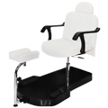 | 1 | ☐ Yes ☐ No
 | Massage Oil Heating Device  Oil/lotion/cream heating, automatic heating system, min 40W, 25 minutes maximum needed to heat massage oil, additional massage oil bottle | 1 | ☐ Yes ☐ No
 | Manicure Table Draft Fan  Mountable manicure table draft fan with appropriate bag for dust collection  Power: 25 W minimum  Similar to the picture below:  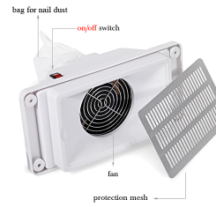 | 1 | ☐ Yes ☐ No
 | Manicure Extractor Fan (table mount)  Operating at 220V; 50HZ; power: 25W minimum, Colour: white, table mount  Similar to the picture below  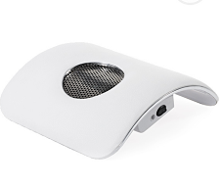 | 2 | ☐ Yes ☐ No
 | Electric Nail File  Filing bits 6 pcs (2 coarse, 2 medium coarse, 2 fine), Diamond bits 4-6 pcs, Filing ring 5-7 pcs, Filing ring bit 1, Twist lock bit changing system, Rpm minimum 28000 /min, Voltage 220-230V, Frequency 50/60Hz, Power minimum 30W, Output power control  Rotation direction change switch  Speed adjustable during operation  Similar to the picture below:  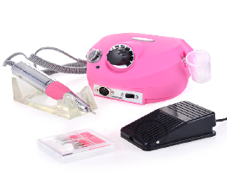 | 5 | ☐ Yes ☐ No
 | Stone Heater  Dimensions (HxWxL)minimum 35x25x15cm  Capacity: minimum 6 lit, Temperature adjustment option, Operating at (power and voltage) minimum 700 W, 220-240V  Handles for safe transportation of unheated stones. | 1 | ☐ Yes ☐ No
 | Pedicure Tub  Capacity 8 litres minimum, Operating mode  220V-240V, 50HZ, Power 350 W minimum  Water heating 35°C minimum, 3D foot massage, IR -infrared function, O3- ozone sterilisation, Jacuzzi system, Minimum 50 foot area massaging points, Rotating ball foot massagers, Pedicure pumice stone, Anti-slip,  Weight 5kg maximum | 3 | ☐ Yes ☐ No
 | Combined Wax Warmer  Volume: minimum 800 ml + 3 mono  2-6 wax cartridges for cold wax  1 hot wax tin, dimensions  temperature range minimum 40°C - maximum 110°C | 3 | ☐ Yes ☐ No
 | Professional Cosmetics Case  Cosmetics case, foldable, minimum 22x36x25cm  Similar to the picture below  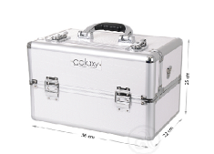 | 1 | ☐ Yes ☐ No
 | Nail Drying LED Lamp  Power: minimum 15 - maximum 40W  Digital display, Drying time Timer: minimum 5 - maximum 100 sec, 5 finger drying, Constant operation: from 1s to 90s, Removable bottom, LED diodes, Heat resistant casing,  Sensor on- and off-switch  Similar to the picture below:  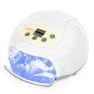 | 1 | ☐ Yes ☐ No
 | Magnifying Glass With Light  Voltage: 220V/50Hz, Power: 22W function  Large magnifier - 4 x minimum  Small magnifier glass - 10 x minimum  Similar to the picture below:  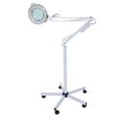 | 1 | ☐ Yes ☐ No
 | Manicure – Hand rest with Dust Collector  Desirable but not obligatory colour - black  Operating at 220-240V, 50HZ; fan power 25 W maximum | 1 | ☐ Yes ☐ No
 | Nail Trainer  Hand with flexible long arm. The hand serves for training and education and to master the manufacture of artificial nails in various forms. Bendable and including a finger position adjustment option.  Similar to the picture below:  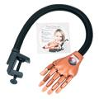 | 1 | ☐ Yes ☐ No
 | Hot/Cold Nail Polish Dryer  Operating at 220/240V;50/60Hz | 1 | ☐ Yes ☐ No
 | Dry-Heat Steriliser  Casing metal, voltage 220V 50/60Hz, power/consumption 250W minimum,  weight 6 kg maximum, intended for sterilising metal and glassware in temperatures up to 250°C, automatic temperature control  Similar to the picture below: | 1 | ☐ Yes ☐ No
 | Paraffin Melter, Aluminium  Dish for paraffin melting made of aluminium,  Operating at 220-240V, 50HZ, power - 150W minimum - 400W maximum, Paraffin heating time 180 minutes maximum.  Brush for paraffin application.  Similar to the picture below:  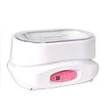 | 2 | ☐ Yes ☐ No
 | Double Hot Wax Warmer  Capacity 6 kg minimum, Operating at 220-240V, 50HZ, power 400W minimum  Adjustable temperature, Stainless steel filter, 1-2 temperature control thermostats  temperature control up to 120°C  Similar to the picture below:  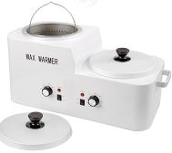 | 1 | ☐ Yes ☐ No
 | Hot Wax Warmer  Capacity 400g, Operating at 50/60HZ; 220/240V, Power 70 W minimum | 1 | ☐ Yes ☐ No
 | Trio Wax Cartridge Heater with Base  Purpose: this device is intended for cold waxing, Cartridge size: 100ml, Number of cartridges: 3, Power indicator  Operating at 50/60HZ; 110/230V  Similar to the picture below:  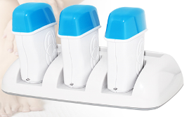 | 1 | ☐ Yes ☐ No
 | UV Lamp  Power: 35W minimum, Operating at: 230V, 50/60 Hz, 3 timer settings: 120sec/180sec/constant operation  Option to simultaneously dry polish and UV gel | 2 | ☐ Yes ☐ No
 | UV lamp with Fan  Operating at 230V, 50/60Hz, Power 30W minimum, Timer: 2, 3, 4, minutes with option to to extend time to 5, 6, 7 minutes, Individual functions light indicator  Option to simultaneously dry polish and UV gel on 2 hands, UV lamp | 1 | ☐ Yes ☐ No
 | UV LED Nail Lamp  UV lamp power 32W (4x8W) minimum  LED lamp power 14W minimum  Operating at 230V, 50/60Hz | 2 | ☐ Yes ☐ No
 | Volcanic Stone set  Set of minimum 45 volcanic stones  Similar to the picture below:  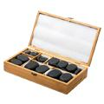 | 2 | ☐ Yes ☐ No
 | 3 in 1 Multifunctional Device  Microdermabrasion, Ultrasound Waves and Hot&Cold Massage, MICRODERMABRASION  Microdermabrasion is peeling off the surface layer of the epidermis and simultaneous stimulation of circulation and lymphatic drainage.  ULTRASOUND - Ultrasonic  1. Uses deep penetration of the 1,000,000 Hz ultrasonic wave to provide a gentle and imperceptible tissue massage, simultaneously stimulating blood circulation and the metabolism. Furthermore, cell activity is restored and nutrient elements are more easily absorbed.  2. Assists in cell rejuvenation and quicker release of toxins, making the skin younger and more beautiful.  3. Accelerates the process of removing fat from the body, i.e. its faster burning.  HOT/COLD TREATMENT:  Swelling reduction, erythema removal, pain reduction, fatty tissue regulation. Cold massage cools the skin, removes red marks, calms the skin, soothes the pain. Massage in linear or circular motion. Hot massage helps in product absorption, accellerates blood and lymph circulation, quickens cell metabolism and activates skin surface metabolism.  Similar to the picture below:  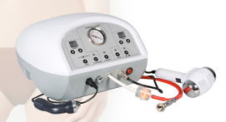 | 1 | ☐ Yes ☐ No
 | 5 in 1 Device  Spray, Vacuum, High Frequency, Peeling, Galvanic Current,  Spray: applying lotion, tonic and serum with deep spraying into the skin.  Vacuum: Massage, squeezing out and vacuuming skin flaws, wrinkle removal, increasing skin elasticity, fat deposit retrogression, a gentle lifting effect.  High frequency: Electrotherapy, skin sterilisation and disinfection.  Skin peeling: Cleaning and massaging the surface of the skin.  Jonos-Galvanic Current: positive and negative voltage functions. Depending on the polarity it can achieve natural penetration of elements into the tissue, balancing out acids and bases with the acceleration of blood circulation and the metabolism.  Similar to the picture below:  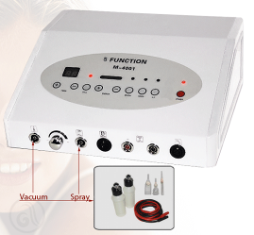 | 1 | ☐ Yes ☐ No
 | Interference Current Device  Voltage: 220 V, 50-60 Hz, Electricity consumption/power: 40 W minimum, Output frequency 1000 Hz - 4000 Hz, Electrodes  4 silicone - 8 silicone, 2 independent channels, Intensity adjustment, Timer with shut-off function, LED diode indicator | 1 | ☐ Yes ☐ No
 | Magnetic Therapy Device  Voltage: 220 V, 50-60 Hz, Electricity consumption/power: 25 W minimum, Output frequency 27,124MHz, Output voltage  L(5mT) minimum and H(10mT) minimum  2 independent channels, 2 magnetic strips  2 magnetic blankets, Light detector of magnetic field interruption, LED diode indicator | 1 | ☐ Yes ☐ No
 | Mesotherapy Device  Voltage: 230 V, 50-60Hz, Electricity consumption/power: 10 W minimum  Phial input speed adjustment  Treatment duration adjustment  Number of therapeutic tips: 2-4pcs  Microprocessor controlled, Soft-touch commands, Sound alarm | 1 | ☐ Yes ☐ No
 | Diamond Tip Microdermoabrasion Device  8-10 diamond tips of various sizes and grain sizes, Serbian language software, LCD screen, variable vacuum suction power  stainless steel handles  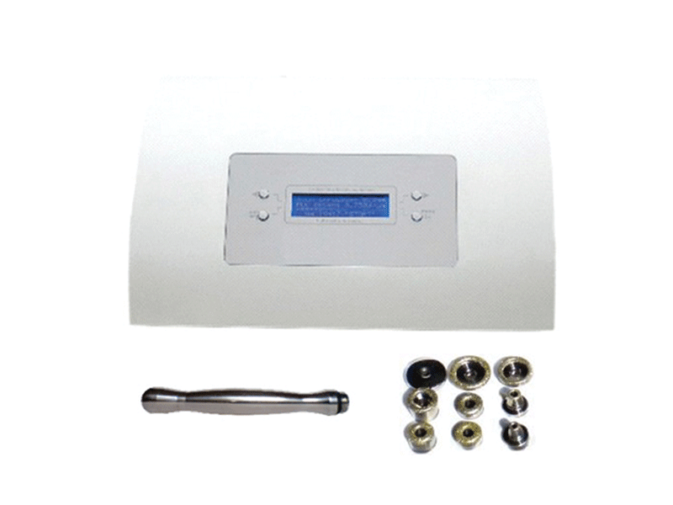 | 1 | ☐ Yes ☐ No
 | Ultrasound cavitation device  Voltage: 230 V, 50-60 Hz, Electricity consumption/power: 10 w minimum, operating frequency: 28-170 kHz  Operating modes: 2 programs - 6 programs  With or without electro-stimulation  Therapy duration adjustment  Number of therapeutic tips: 1 -2kom  Microprocessor controlled, Soft-touch commands, Sound alarm | 1 | ☐ Yes ☐ No
 | Aqua detox  Voltage: 230 V, 50-60 Hz, Electricity consumption/power: 25W minimum  Maximum input current 2A, Maximum output voltage 2V - 6V, Soft-touch commands  Sound alarm, Microprocessor controlled device, Microprocessor time indicator  Microprocessor sensor for presence of person, Digital automatic programs not less than 5, Program switcher | 1 | ☐ Yes ☐ No
 | Electro stimulator  Voltage: 230 V, 50-60 Hz, Electricity consumption/power: 10W minimum, Signal frequency 10-150Hz, Number of electrodes  24 silicone or aluminium minimum  Number of channels not less than 12  Microprocessor controlled, LED on/off indicator, Relaxation settings, Programs not less than 4, Timer 10-60min | 1 | ☐ Yes ☐ No
 | 14 in 1 Multifunctional Beauty Instrument  Vacuum: Massage, squeezing out and vacuuming skin flaws, wrinkle removal, increasing skin elasticity, fat deposit retrogression, a gentle lifting effect.  Spray: applying lotion, tonic and serum with deep spraying into the skin.  High frequency: Electro therapy, skin sterilisation and disinfection.  Spot remover: removing spots, freckles, age spots and scars made by unprofessional squeezing out of acne.  Jonos-Galvanic Current: positive and negative voltage functions. Depending on the polarity it can achieve natural penetration of elements into the tissue, balancing out acids and bases with the acceleration of blood circulation and the metabolism.  Skin peeling: Cleaning and massaging the surface of the skin.  Hot&Cold Treatment: Swelling reduction, erythema removal, fatty tissue regulation.  Ultrasound: Detailed explanation of this function provided with DMX-2025 device  Vapozone: Ozone and aromatherapy. Three steam settings.  Massage: Special massaging part (vacuum vibrating balls), increasing skin elasticity, cellulite reduction and stretch mark removal.  Wood's lamp: Skin analysis  Loupe: minimum 3x magnifying glass  Similar to the picture below:  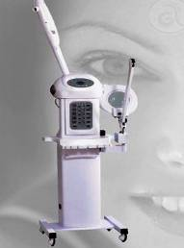 | 1 | ☐ Yes ☐ No
 | 3 in 1 Cosmetics Device  3 in 1 device: high frequency, loupe, vapozon  Treatments:  1. Facial Steam Treatment  2. Ozone sterilisation  3. Electrotherapy  Vapozone is a device that sprays steam. Demineralised water is exclusively use, heated and turned into steam. Ozone is mixed with the steam, ionizing it. Ionized steam the device makes gently stimulates the skin, accelerates blood circulation and metabolism, hydrates the skin and makes it fresh and elastic.  Its application in cosmetics is in preparing the face for a thorough cleaning, achieving deep disinfection of the skin, opening pores and deoiling (oily and combination) skin.  Similar to the picture below:  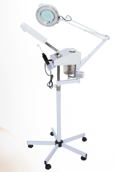 | 1 | ☐ Yes ☐ No
 | 17 in 1 Multifunctional Beauty Device  Functions:  - Magnifying loupe  - Hot towel cabinet  - High frequency / facial brush  - Facial Scrub / Gloves  - Spot Removal / Hot&Cold Massage  - Galvanic Current / Ultrasonic Skin Scrubber  - Wood's Lamp Skin Analyser  Add-ons with the machine and all of its functions:  Vacuum/ Spray / Microdermoabrasion:  - Vacuum/Spray add-ons  - Microdermoabrasion  High Frequency / Face Brush:  - High frequenncy add-ons  - Face Brushes  Skin Scrubber/ Gloves:  - Scrubber - add-ons  - Gloves  Spot Removal / Hot&Cold Massage:  - Spot removal - add-ons  - Hot&cold massage  Galvanic Current / Ultrasound:  - Galvanic current  - Ultrasound  Wood's Skin Analysis Lamp  Steriliser and UV Towel Heater  Similar to the picture below:  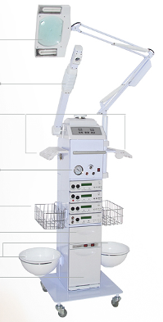 | 1 | ☐ Yes ☐ No
 | Multifunctional Device  Purpose: Professional beautifying device equipped with a computer program focusing on critical points in weight reduction, body shaping and chest strengthening.  Programs: Weight reduction, body shaping and chest strengthening programs, Number of rubber patches: Not less than 16, Number of self-adhesive patches: Not less than 16  (large and small self-adhesive electrodes included), Self-adhesive Elastic Straps  Elastic straps for attaching rubber conducting patches Elastic straps of various sizes split into two groups. The first group includes strips for the abdomen, waist, thighs, calves and hands. The second group includes belt-shapes strips used on the chest.  Program selection display, Not less than 8 preset programs.  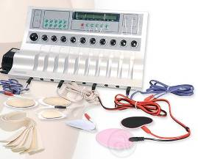 | 1 | ☐ Yes ☐ No
 | Tanning Booth Tower  Body lamps / power not less than 45 / 180 W minimum, Body lamps in the upper shelf,  Body lamps in the lower shelf, Face lamps  Electronic dimmers, Power 8-kW/h minimum  Ventilation duct 200 mm minimum, MP3  Speakers | 1 | ☐ Yes ☐ No
 | Tanning Booth Vertical Tower  vibration plate, body lamps not less than 48, lamp power 120W minimum, electricity consumption 10 kW minimum, three-phase power source, digital timer | 1 | ☐ Yes ☐ No
 | Tens Stimulator  Voltage 220 V, 50-60 Hz, Electrical Consumption/power 5W minimum, 2-4 independent channels, Electrodes not less than 4 electrodes, output frequency 10 Hz minimum, Intensity adjustment, modulation adjustment, End of stimulation sound alarm,  Timer digital | 1 | ☐ Yes ☐ No
 | Physical Therapy Ultrasound  Voltage: 230 V, 50-60 Hz, Electrical consumption/power 5 W minimum, Ultrasound frequency 1 and 3 MHz, Modulation impulse, Ultrasound wave intensity 0.5 W/cm2, times with shut-off function, number of ultrasound tips - 1 pcs multi frequency, microprocessor controlled,  LED power indicator | 1 | ☐ Yes ☐ No

Delivery requirements –– Comparative Data Table

UNOPS Requirements |  | Is quotation compliant? Bidder to complete | Details  Bidder to complete  Insert details
Delivery time | Bidder shall deliver the goods 20 (twenty) calendar days after Contract signature. | ☐ Yes ☐ No
Delivery place and Incoterms rules | DAP (Delivered at Place) as per Incoterms 2010.  Delivery, offload and installation of the equipment on the beneficiaries’ premises are included in the price.  Beneficiaries are placed in the municipalities of Novi Pazar, Priboj, Nova Varos, Zitoradja and Vranje.  Net of any direct taxes, customs duties and indirect taxes and VAT. | ☐ Yes ☐ No
Consignee details | The exact address the goods should be delivered and offloaded to, as well as all other relevant details, will be available upon contract signature. | ☐ Yes ☐ No
UNOPS Right to vary requirements | At the time the Contract is awarded, UNOPS reserves the right to vary the quantity of the goods and associated services specified above, provided this does not exceed +/- 20%, without any change in the unit prices or other terms and conditions of the RFQ. | ☐ Yes ☐ No

The offered goods and related services (if applicable) are in accordance with the required specifications and requirements specified in Section III: Schedule of Requirements.

☐ Yes ☐ No
ANY DEVIATION MUST BE LISTED BELOW:
___________________________________________________________________________________________________________________________________________________________________________________________________________________________________________________________________________________________________________________________________________________________________________________________________________________________________________________

Name : _____________________________________________________________

Title : _____________________________________________________________

Date : _____________________________________________________________

Signature : _____________________________________________________________

Form D: Previous experience form
RFQ reference no: [insert RFQ reference No.] ______________________________________
Name of Bidder: [insert name of Bidder] ______________________________________

Description of services/goods | Country | Total amount of Contract | Contract Identification and Title and  Contact details of Client:  (Name, Address, telephone, email, fax) | Year project was undertaken

Name : _____________________________________________________________

Title : _____________________________________________________________

Date : _____________________________________________________________

Signature : _____________________________________________________________75 00ax: +45 45 33 75 01

